***Support & Tickets Report***

**Total Tickets:** *2380*

| **STATUS** | **%** | **# TICKETS** |
| --- | --- | --- |
| Done | 94.25% | 2267 |
| In progress | 1.83% | 21 |
| Scaled | 2.80% | 74 |
| Won't do | 1.12% | 18 |

**Distribution by Category:**

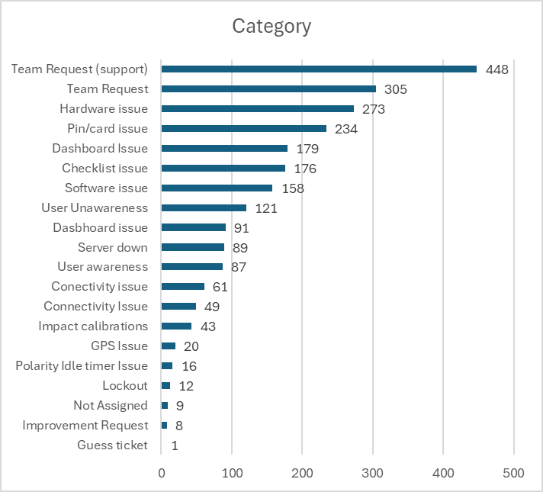

**Tickets with more than 10 days open**

| No | Customer | Reported | Issue | Days open |
| --- | --- | --- | --- | --- |
| 2879 | Novolex | Reene | They have many vehicles without connection. | 23 |
| 2895 | Matalco USA LLC | Josh | We believe the only test unit they have has a damaged expansion module, since it seems like they have relay issues and the system is currently on the version Y. | 15 |
| 2928 | Greenheck | Jose | They have a connectivity issue that causes them to receive the impact alerts delayed. | 15 |

**2879**: This novolex location (Cornersville) has really poor connectivity in the area, the vehicles have had a hard time receiving messages and it has been a challenge to support, chris reeves went and installed a new sim since renee mentioned Verizon was the least bad service provider in the area, currently this test sim hasn't had and connection since the 27/1/2025.

**2895**: Jose Colon sent an email on the 23/1/2025 to the dealer asking for a tech to visit and troubleshoot the system and change what needs to be changed. We have asked Jose a couple times how everything was going but haven't received any response.

**2928**: We are currently waiting for the release of the firmware F to reduce the connectivity issues they are experiencing

**USA Scaled Tickets**

**Total tickets: 25**

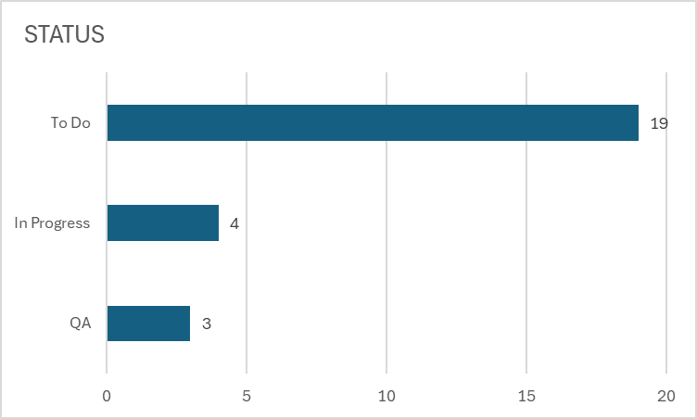

***Priority  
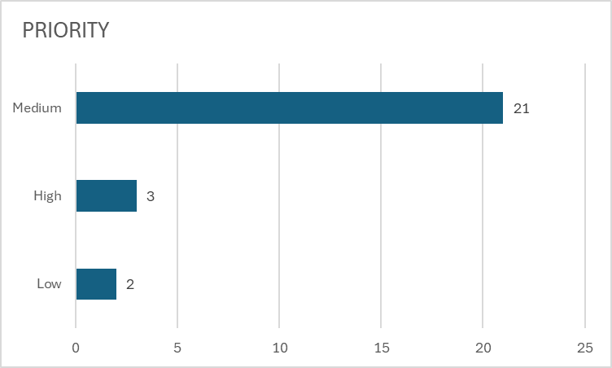***

*Highest average days opened = 124 days*

***USA Tickets with Top Priority***

***Jan Sprint***

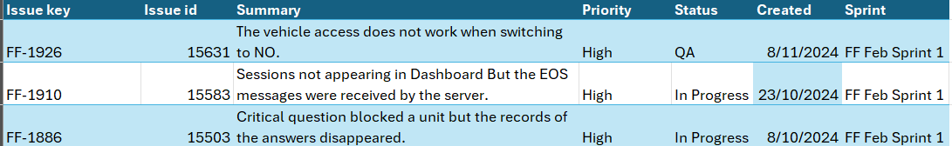

***More Information about Escalated Tickets*** [***here***](https://docs.google.com/spreadsheets/d/19lA6QXLt4Sib9_wqemXRmXZpkWHVSTKz8TqkDGoAtkw/edit?gid=21054516#gid=21054516)

***Global Scaled Tickets***

***Total Tickets:*** *244*

| ***Status*** | ***Count of Status*** |
| --- | --- |
| ***In Progress*** | ***23*** |
| ***QA*** | ***19*** |
| ***RELEASE*** | ***5*** |
| ***To Do*** | ***197*** |

***Priority***

| ***Priority*** | ***Count of Priority*** |
| --- | --- |
| ***Highest*** | ***2*** |
| ***High*** | ***17*** |
| ***Low*** | ***3*** |
| ***Medium*** | ***222*** |

***Global Tickets with Highest Priority***

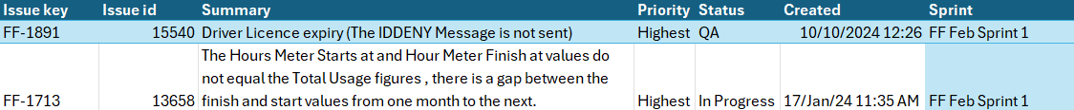

[***Jira Detailed Information***](https://collectiveintelligence.atlassian.net/jira/software/c/projects/FF/issues/?jql=project%20%3D%20%22FF%22%20AND%20status%20IN%20%28%22In%20Progress%22%2C%20RELEASE%2C%20QA%2C%20%22To%20Do%22%29%20ORDER%20BY%20status%20ASC%2C%20created%20DESC)